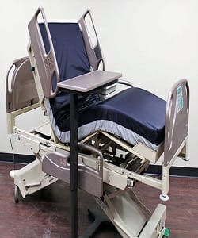

Universal Hospital Bed

$412.15

Availability: In stock

**Description:**

The electrical Bed, part of the universal Collection, is designed with a lavish modern style in premium linen upholstery. Steel and additional metal legs to ensure stability and support. Black Eco Leather King Size Platform Bed. Long life battery is also present in this bed.